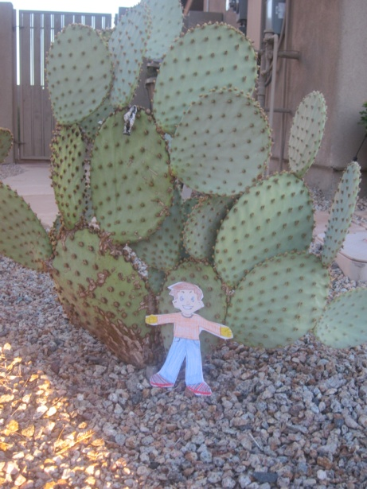Flat Stanley’s Trip to Goodyear, Arizona

Dear Aidan,
Thank you so much for sending us Flat Stanley. We had a lot of fun taking photos of him. First he helped us decorate for Halloween. Then we drove out to the desert to look for a Saguaro Cactus so Stanley could see one.
Did you know these cacti can live to be up to 200 years old. They grow very slowly, a 10 year old cactus can be only 1 ½ inches high.
Next Stanley and the family were quite hungry so we went to the shack and got the usual 5lb chicken burritos. YUM!
See you in December! Love Steph, Jeff, Owen and B
